Lebanese American University



MCE 410 – Mechatronics System Design I
Fall 2025

Autonomous Cup Guessing Game System

Final Project Report

James Makhlouf | 202305247 | Romy Matar | 202300816
Robin Sarhane | 202301298

Problem Statement
Traditional guessing games, such as the “cups order” game, typically require a human moderator to shuffle the cups, verify the player’s guess, and declare the results. This limits autonomy and repeatability. Our project aims to eliminate human intervention by developing an automated system that manages the game entirely ensuring fairness, consistency, and an engaging player experience.

System Requirements
- Cup Setup & Randomization
  - Three cups of different colors are placed in random order.
  - The system automatically shuffles or ensures randomness without revealing the order to the player.
- Game Initialization
  - A start button begins the round and activates the cups’ shuffling which then starts a timer.
- Player Interaction
  - The player places the cups based on their intuition in the designated spots
  - The system autonomously compares the guess with the actual arrangement.
- Computer Vision Processing
  - A camera captures the cups’ arrangement.
  - A computer vision algorithm detects the colors and determines the number of cups in the correct places.
- Feedback & Results
  - After each round, the system informs the player how many cups are in the correct position.
  - When the player guesses the correct order, the system notifies them of the win and stops the timer.

Requirements Analysis
Table 2 - Requirement Analysis
Requirements |  | Unit  Value | Requirements Type
 |  |  | Mandatory Req. (fixed) | Soft  Req. | Quantitative  Req. | Qualitative  Req.
Mechanical Structure and Dimensions | Shuffling  Conveyor Belt | Height: 7cm  Width: 10cm  Length: 50cm | Fixed |  |  | Qual.
 | Display Conveyor Belt | Height: 7cm  Width: 10cm  Length: 30cm | Fixed |  |  | Qual.
 | Cups | Height: 7cm  Small Diameter: 4cm  Large Diameter: 7cm | Fixed |  |  | Qual.
 | Box | Height: 40cm  Width: 60cm  Length: 70cm | Fixed |  |  | Qual.
Mechanical Skeleton | See Figure 2 |  |  | Soft |  | Qual.
Power | Electric Battery | 5-12V |  |  |  | Qual.
Actuators | Linear Actuator |  | - | Soft | Quan. | Qual.
 | DC Motor |  | Fixed |  | Quan. | Qual.
Sensors | IR Sensor | Size: 5mm  Wavelength: 940nm | Fixed |  | Quan. | Qual.
Controller | Raspberry Pi |  | Fixed |  |  | P.
 | Camera for Computer Vision |  |  | Soft |  | Qual.
Manual Control | Push Button |  |  | Soft |  | Qual.
User Interface | LCD | Package Size:  9.00cm x 5.00cm x 2.00cm |  | Soft |  | Qual.

Functional Diagram
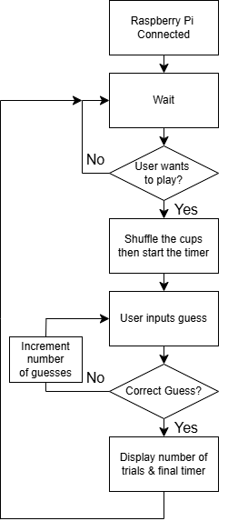  Figure 1 - Functional Block Diagram of the System | The figure represents the functional block diagram of our project. After powering the Raspberry Pi, the system enters a state of hold in which it waits for the user to start the game. If so, the cups inside the box are to be shuffled randomly, then the timer starts. While the user hasn’t identified the correct sequence, the game still loops and increments the number of guesses. After that, the timer stops, and the final number of trials are displayed to the user. The system then waits for another round.

Solution Suggestions based on Functions
Table 1 - Morphological Table, Analysis, and Evaluation of the Best Solution
Function | Solution 1 | Solution 2 | Solution 3
System activation | On-Off Switch | Touch Activation | Pushbutton
User interface | Touch Screen | LCD | Keypad
Check Activation | On-Off Switch | Touch Activation | Pushbutton
Control System | Raspberry Pi | Arduino
Belt Actuator | DC Motor | Servo Motor | Stepper Motor
Cup Pushing | Servo Motor | Stepper Motor
Drive | Analog H-Bridge | IC H-Bridge
Cup Checking | Color Sensor | Camera (CV)
Cup Shuffling | Mechanical | Software
Winning | Active Buzzer | LCD | LEDs
Counting | Counter | Programmed Unit
Timer | Timer | Programmed Unit
Cup Shuffling Solutions Explanation:
      - Mechanical
Using two conveyor belts, along with a linear actuator and three IR sensors, we can ensure that the cups are positioned according to the desired shuffled order. The linear actuator mentioned may be a solenoid, a pneumatic or hydraulic actuator, or a servo motor with mechanical conversion to turn rotation into linear motion. Below is a representation of this system.
      - Software
Using RGB LEDs and transparent cups, we may change the color of each cup using software.

Optimal Solution
Based on the evaluation of the different alternatives, we opted for the following optimal solutions: the control system is handled by a Raspberry Pi and when it is powered on, the system is activated. A pushbutton is used to start the game round and record the user’s guess using a Raspberry Pi camera with computer vision. Electric motors will actuate the conveyor belts while a servo motor is used to push the desired cups onto the displaying belt. The rotating motion is converted to linear using a 3D printed design. Lastly, the LCD is used as an interface, guiding the user throughout the game and displays the total time and number of valid trials at the end.
This is the setup of our cup shuffling station:
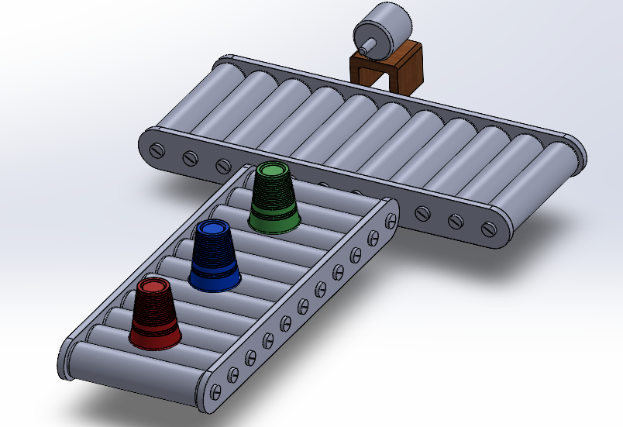
Figure 2 - 3D Model Design of our Cup Shuffling System

Hardware Block Diagram and Connections
The following two pictures represent a vague connection of our hardware.
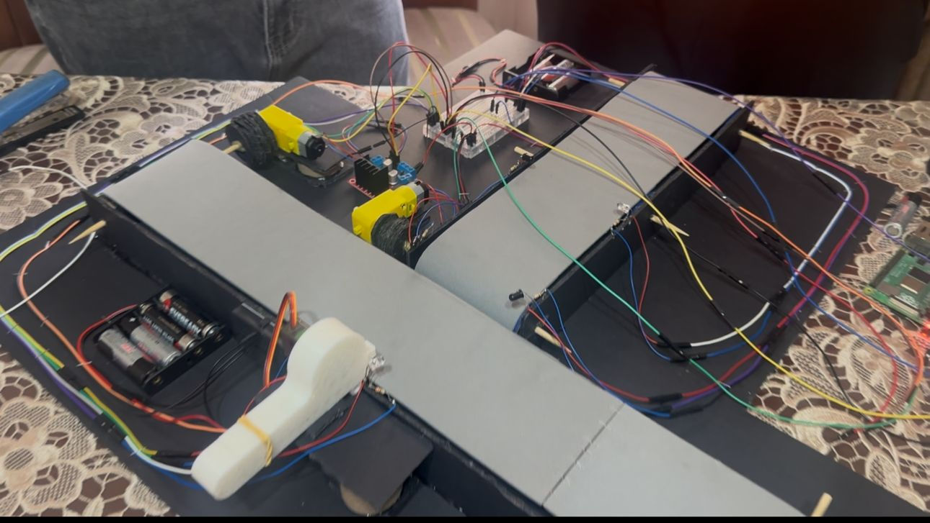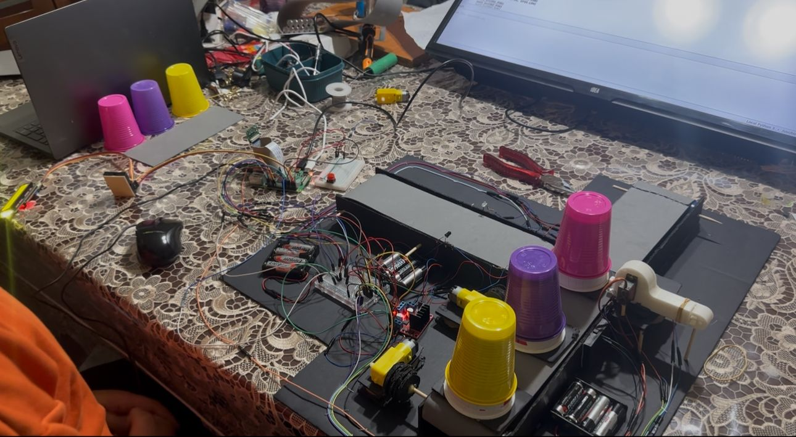
Battery Cases
H-Bridge
IR Emitters
IR Receivers
Linear Actuator
Servo Motor
DC Motors
We note that no block diagram was needed since most of our connections are directly linked to the Raspberry Pi.

Software General Algorithm

Cup Shuffling:
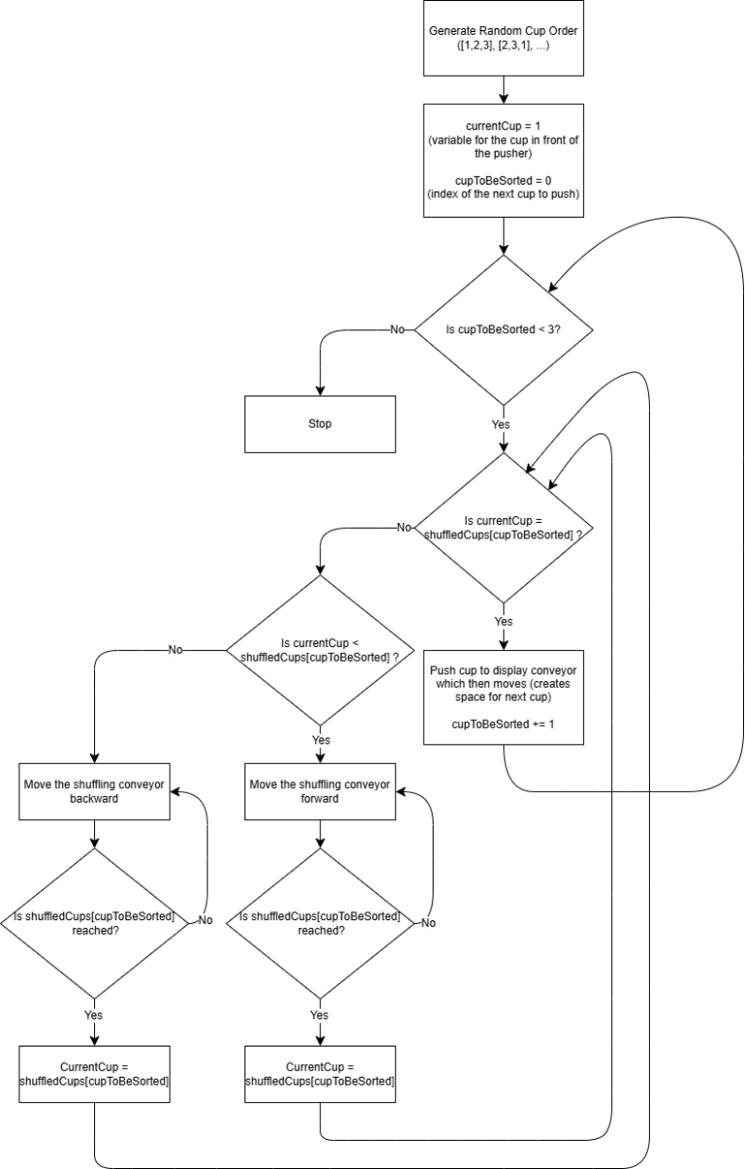
Figure 3 - Flow Diagram of the Mechanical Shuffling
The process begins by generating a random cup order, for example [1, 2, 3] or [2, 3, 1].
Two variables are then initialized:
cupToBeSorted = 0: This is the index of the next cup in the generated order that needs to be pushed.
currentCup = 1: This represents the cup currently positioned in front of the linear actuator.
The algorithm first checks whether there are still cups to be sorted (cupToBeSorted < 3). If not, the process stops. If there are, the system compares the current cup with the cup that needs to be pushed (shuffledCups[cupToBeSorted]):
If currentCup = shuffledCups[cupToBeSorted], the linear actuator activates, moving that cup onto the display conveyor. The display conveyor then shifts to make room for the next cup. At this point, cupToBeSorted is incremented by 1 to move to the next required cup in the order.
If currentCup < shuffledCups[cupToBeSorted], the shuffling conveyor starts moving forward until the required cup is brought to the linear actuator. When said cup is in position, currentCup is updated to shuffledCup[cupToBeSorted].
If currentCup > shuffledCups[cupToBeSorted], the shuffling conveyor moves backward instead. When the desired cup reaches the linear actuator, currentCup is updated to shuffledCup[cupToBeSorted].
This cycle continues until all cups have been sorted and pushed according to the random order.

Cup Detection:
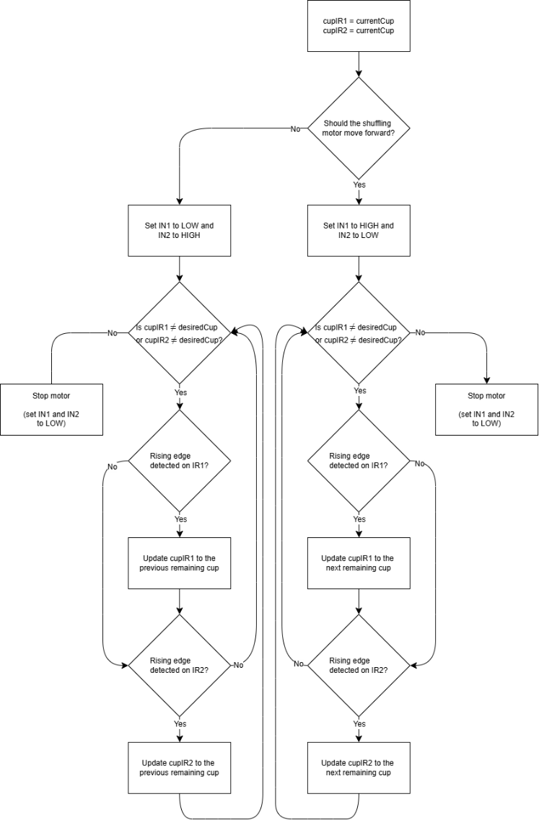
Figure 4 - Flow Diagram of the Cup Detection
The process begins by checking whether the shuffling conveyor should rotate forward or backward. Two variables, cupIR1 and cupIR2, are then initialized to the value of currentCup, representing the cup currently detected by each of the two IR sensors. To prevent false triggers from noise or rapid fluctuations, two timers (IR1Timer and IR2Timer) are started, and two detection states (IR1Detected and IR2Detected) are recorded as the previous readings of the sensors.
These timers enforce a minimum delay of 0.15 seconds between valid detections, acting as a built-in debouncing mechanism so the system does not register the same cup multiple times as it passes the sensor.
The conveyor motor is then activated in the correct direction. The algorithm continuously checks whether both sensors have detected the desiredCup. If not, it monitors the IR sensors for a rising edge (a function was used where a HIGH value represents a cup in front of the IR sensor). A rising edge is only considered valid if the sensor’s current reading differs from the last stored state and at least 0.15 seconds have passed since the previous detection for that sensor.
Whenever a valid rising edge occurs on IR1, the system updates cupIR1 to the next remaining cup in the rotation order (moving forward or backward depending on the direction). The same procedure is applied independently to IR2. This allows the program to track which cup is physically passing under each sensor as the conveyor turns.
This checking cycle continues until both cupIR1 and cupIR2 match the desiredCup. When that happens, the conveyor motor is turned off, stopping the belt with the desired cup positioned under both IR sensors and ready to be pushed.
      - Computer Vision:
The process begins by starting the pi camera and waiting for a push button press. When that occurs, a picture is taken, and the cup order is detected using hsv filters. The system then checks whether the detected order is valid or not; an invalid guess is one that is missing a cup or contains duplicates. If an invalid guess is registered, the lcd displays so to the user and waits for another button press. When a valid guess is entered, it is compared to the shuffled order and continues the program accordingly.

User Interface:
The LCD acts as the main user interface, displaying short messages that guide the player through all stages of the game (starting prompts, instructions, guess feedback, and the final results). Whenever the game needs to communicate something to the user, it updates one or both rows of the LCD using a lock to prevent multiple parts of the program from writing at the same time.
During the guessing phase, a separate timer thread is started. This thread continually updates the top row of the LCD once per second with the elapsed time, while the main program handles cup detection and user guesses. When the game ends, the thread is stopped, and the LCD shows the final time and number of guesses before resetting for the next round.

Game Loop
On the LCD the system is displaying “Press Button to Start Game”. When the user is ready, they must press it and then the game begins. The game cycle starts by shuffling the cups’ order which is dictated randomly using software. The shuffling algorithm is explained in Software General Algorithm, section I – Cup Shuffling.
When the shuffling ends, the LCD displays to the user that they have to press the pushbutton in order to register their guess. A timer is also displayed to keep track of the time until they correctly guess the order. The user starts putting the cups in a random order and presses the button. The LCD shows the number of correct cups which aids the user in their next trial. Each iteration is added to a counter which is then displayed on the LCD at the end of the game along with the total time.

Problem Faced
Numerous problems have been encountered while the creation of this project. From software to hardware, each step has been delayed and repeated enough times.
In hardware:
- The creation of an autonomous system requires fool proof checks and accuracy which was opposed by the delay when the controller overheats due to intensive use. The latter was originated from the wireless and headless setup of the Pi which was then rectified by using a monitor, keyboard, and mouse.
- The material used for the belts was stretchy, which introduced a loss in energy and required the motor to increase its power thus leading to wear. A temporary solution was to tighten it more.
- Due to high loads, the DC motors require high power which we provided using an additional set of batteries.
- The first prototype of the linear actuator was inaccurate due to faults in the printer itself, so the final part was manufactured using another printer.
In software:
    - Incompatibility of the Raspberry Pi Camera led to a massive delay in the project’s progress. This problem was later identified, and a new camera was bought.
    - The IR sensor introduced rapid fluctuations and debouncing error as the cup edge passes in front of it, which lead to a miscalculation of the current cup to, rectify this issue, we slightly modified the logic of the code by increasing the sample time (refer to Software General Algorithm, section II – Cup Detection).

Bills of Material
Material | Unit Price | Unit | Quantity | Total Price | Manufacturer
Raspberry Pi 4 | Priorly Available | pcs | 1 | - | -
Picamera V1.3 | $4 | pcs | 1 | $4 | Dynamic Solutions
Hot Glue Gun | Priorly Available | pcs | 1 | - | -
LCD Display | $4 | pcs | 1 | $4 | Dynamic Solutions
Push Button | $0.25 | pcs | 1 | $0.25 | Dynamic Solutions
Servo Motor MG90s | $4 | pcs | 1 | $4 | Dynamic Solutions
DC Motor | $0.9 | pcs | 2 | $1.8 | Dynamic Solutions
IR Sensor | $0.5 | pcs | 3 | $1.5 | Dynamic Solutions
H-Bridge L298N | $2 | pcs | 1 | $2 | Dynamic Solutions
Batteries | $7 | pack | 1 | $7 | Dynamic Solutions
LED | $0.05 | pcs | 1 | $0.05 | Dynamic Solutions
Resistors | $4 | pack | 1 | $4 | Dynamic Solutions
Breadboards | $0.9 | pcs | 3 | $2.7 | Dynamic Solutions
Wires | $1 | pack | 3 | $3 | Dynamic Solutions
Filament for 3D Printing | $23 | pack | 1 | $23 | Dynamic Solutions
Soldering Kit | Priorly Available | pcs | 1 | - | -
Foamboard | $4.5 | pcs | 4 | $18 | Daily Press
Foam Sheet | $3 | pcs | 1 | $3 | Daily Press
Pipes | Priorly Available | pcs | 5 | - | -
Wooden Sticks | Priorly Available | pcs | 1 | - | -
Monitor + Keyboard + Mouse | Priorly Available | pcs | 1 | - | -

